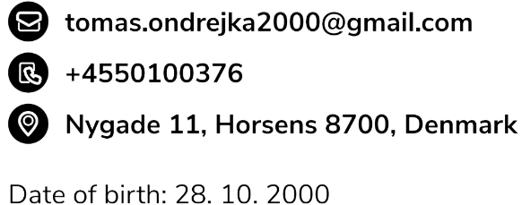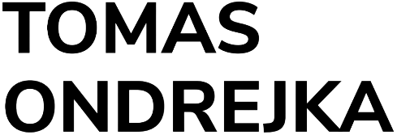 7th May 2022

**Cover letter for Junior Software Engineer Intern at Sony**

Dear Hiring Manager,

I am writing this letter to express my interest in the Junior Software Engineer Intern at Sony. Currently, I am looking for an internship starting in the summer of 2022 with a minimum length of 4,5 full-time months. This position would be a great opportunity for me to use my practical knowledge and skills from school and projects.

I am currently taking a Bachelor‘s degree at Via University College. While working on projects in school, I have developed a skill to adapt to every situation I am in and come up with creative solutions to problems that can occur. My expertise in Git and Github grew significantly. Waterfall and Scrum methodologies were strictly followed during the projects for the highest learning outcome. Our latest project was full-stack development of an application for selling experience products. This project was implemented using Java, Spring, JPA and Swagger for an API documentation.

I am proficient with a number of programming languages, including TypeScript, Java and C#. I am currently employed as a Tech Student Assistant at WhiteAway Group. My responsibilities mainly consist of infrastructure, DevOps and back-end development. I am currently working with the following technologies: Node.js, TypeScript, AWS, Kubernetes, Docker, Terraform and CircleCi. Before, I worked as a Game Developer at TrainYourEyes.dk where I developed JavaScript and TypeScript exercises. My projects are now used for helping people with various types of sight problems. My work experience taught me to efficiently self-manage when working on separate assignments and collaborate in a group environment.

Because of my solid knowledge of programming languages and my passion, I have a foundation for learning new technologies and frameworks that can benefit Sony. I am an excellent team player with attention to detail and with the knowledge required for the position.

Please do not hesitate to reach out if you have any questions about my background, projects or my skills. I look forward to the opportunity to speak with you further.

Thank you for your time and consideration.

Sincerely,

Tomas Ondrejka